The Colorado River- A Case Study
(Modified from “The Colorado River Story” from http://www.esrl.noaa.gov/gsd/outreach/education/Colorado-River-lesson.pdf)

Learning Objectives: Students will be able to use multiple data sources to evaluate the effectiveness of the Colorado River Pact of 1922

Standard Assessed:
- PA Science Standards:
  - 3.3.6.A1. Recognize and interpret various mapping representations of Earth’s common features.
  - 3.3.6.A4. Describe how water on earth cycles in different forms and in different locations, including underground and in the atmosphere.
  - 3.3.7.A6. MODELS/SCALES- Locate significant geological structures using various mapping representations.
  - 4.2.7.A. – Explain how water enters, moves through and leaves a watershed.
    - Describe factors that affect the flow and water quality within a watershed.
  - 4.2.10 – Examine the interactions between abiotic and biotic factors with in a watershed
  - 4.2.12.A. – Examine environmental laws related to land use management and its impact on the water quality and flow within a watershed.

- NGSS Standards:
  - MS-ESS2-4: Global movements of water and its changes in form are propelled by sunlight and gravity.
  - MS-ESS2.C: Water continually cycles among land, ocean, and atmosphere via transpiration, evaporation, condensation and crystallization, and precipitation, as well as downhill flows on land.

Prep Time:

Time to Complete: 3 (45 minute) class periods (1 for data analysis, one to develop proposal and 1 for presentation of proposals)

Materials: Copies of student activities and materials for presentation as determined by teacher (electronic or paper)

Description:
Students will investigate data sources on snowpack, temperature, streamflow and population changes through out the watershed of the Colorado River. They will analyze the impact these factors have on the effectiveness of the Colorado River Pact of 1922 and propose changes to the Pact to help with the current water dilemma in the region.

Prior Knowledge Needed: Students should be familiar with the concepts of the headwaters, watersheds, snowpack and streamflow
The Colorado River- A Case Study
(Modified from “The Colorado River Story” from http://www.esrl.noaa.gov/gsd/outreach/education/Colorado-River-lesson.pdf)

[Overview of story of Colorado River, the invention of the pact and the status of Colorado, present problem for them to review.]

Together we will examine data from various parts of the Colorado River starting in the Rocky Mountains, and continuing into the various communities that rely on the water of the Colorado River to support their lives.

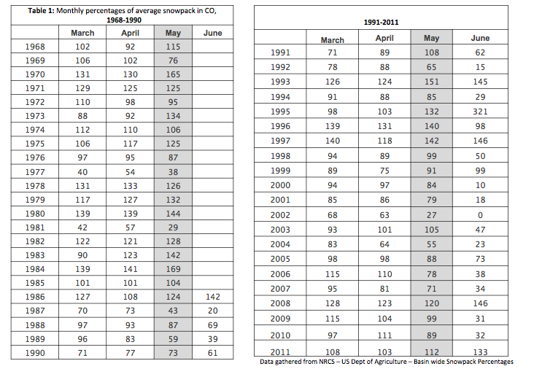
Part 1- Rocky Mountain Snowpack Graphs

The snowpack found in the Rocky Mountains feeds the headwaters of the Colorado River watershed. As the snowpack melts the water flows down the Colorado River.

Question: How has the snowpack in the Rocky Mountains changed over time?

To answer this question, we will need to examine data from the area over a long timeframe. Thankfully, scientists have been studying the Colorado River and we can use the data other scientists have submitting the U.S. Department of Agriculture. Table 1 shows us annual values for each month (March-June) of what percentage of the average snow pack was present at the sample site.
Task: Graph each month’s data separately as scatter plot graph (this can be done by hand or using a graphing program like Excel.) A scatter plot graph means that you will only graph the points, do not try to “connect the dots” like you would in a line graph. Snowpack Percentage should be your y-axis, Year should be your x-axis.
After you have graphed the months versus snowpack data, make a line of best fit on each graph. This will show the trend in the data points, which likely look messy right now.

Analysis:

- What trend did you notice in your graphs? Is the trend the same for all months? Describe the trend using words like “increasing” or “decreasing.” Include how these trends change over time.

- Make a prediction:
  - What do you think is causing this trend?

  - Can you give any evidence to support your hypothesis?

  - Are there other data you would need to investigate your hypothesis? What could this additional information help you to say?

Part 2- Rocky Mountain Spring Temperatures

Use Graph 1 below to expand on your claims from Part 1.

Graph 1- Average Spring temperature (degrees Celsius) at SNOTEL site Cascade in the San Juan Mountain Range of the Rockies, located in the Southwestern part of Colorado.
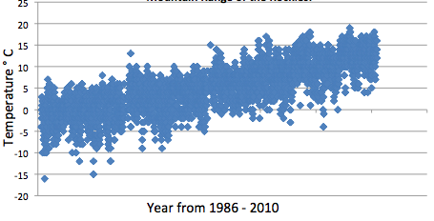

Analysis: What might be the relationship between the information you graphed from Table 1 on snowpack and the information in Graph 1 on temperature?

  - Make a claim:

  - What evidence supports this claim?

  - What reasoning can you give to connect your claim and evidence?

Make predictions: What might be affected by these changes in snowpack and temperature?

Part 3: Streamflow Over Time

Streamflow means the volume and rate of flow of water down a river. Streamflow is dependent on the source of water feeding the river, which in the Colorado River is the snowpack in the Rockies. The more snowpack melt, the greater the streamflow should be. People of the southwest depend on a certain volume of water to flow downriver of the Colorado River- for drinking, bathing, cooking, but also for watering crops and livestock, for industries, even to generate power.

Scientists can look into the past with climate proxies, natural archives of climate information, like tree rings, ice cores, corals, and lake and ocean sediments. This gives them evidence to see what the streamflow was most likely, even though no one collected the data at the time. In 1922, the State of Colorado signed onto a compact with 6 other western states (Arizona, California, Nevada, New Mexico, Utah and Wyoming) located along the Colorado River and its tributaries, who were using the water from the river. When the Colorado River Pact of 1922 was signed, engineers and scientists used about 20 years of data to decide how much water was in the river each year. This is represented in a unit of measure called MAF, or million-acre foot.

Graph 2, below, shows the measured streamflow (observed) compared to streamflow inferred from tree ring evidence (reconstructed) for an important site along the Colorado River, Lees Ferry in Arizona.

Graph 2- Annual Streamflow of the Colorado River at Lees Ferry, AZ, 1900-2000
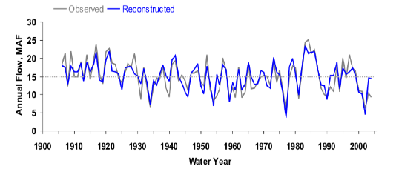
Analysis

- The dotted line in the center of the graph shows what scientists claim is the average streamflow at this point in the river. Do you think this is an accurate claim? Why or why not?

- The graph shows the streamflow, or water supply, of the river. Do you think the demand for water is similar or not?

Part 4: The Colorado River Watershed
The Colorado River watershed is shown in the map below. The key in the top left corner shows which states are in the upper and lower basin as described in the Colorado River Pact of 1922.

There are several reservoirs along the river used to store water. Two examples found on the map are Lake Powell and Lake Mead. These help to make up differences in yearly streamflow, by damming the river to make lakes. However, in these larger bodies of water, evaporation will occur more rapidly than in a flowing river.

The amount of water flowing into the Colorado River from its main tributaries, the Green River and the San Juan River are noted on the map, along with the rates of evaporation from Lake Mead and Lake Powell. Finally, you will see the inflow and outflow of Lake Powell- this indicated the supply (inflow) of the reservoir, the outflow to the lower basin of the river. In order to maintain the reservoirs, the inflow must be more than or equal to the outflow.
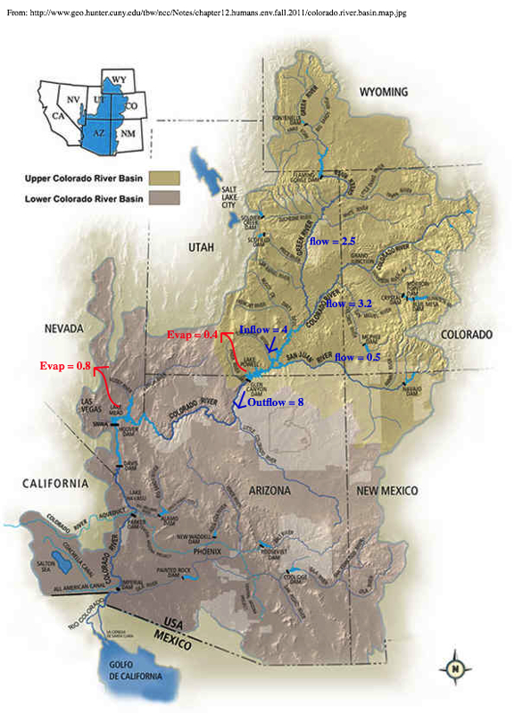
Figure 1 – Map of the Colorado River Watershed

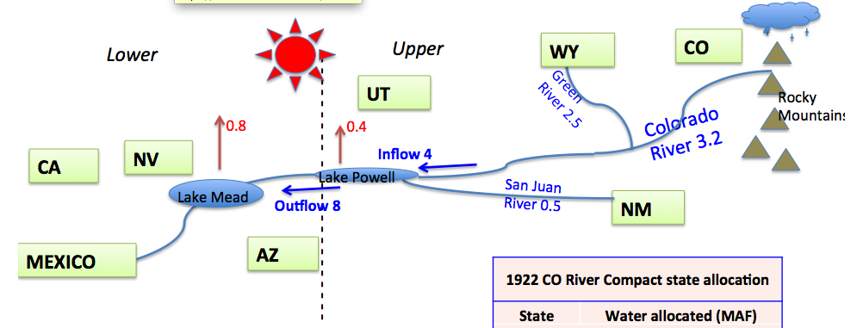
Figure 2- Model of the Colorado River Watershed for year 2002

Table 2- Colorado River Pact of 1922 State Allocations
 | State | Water allocated (MAF)
Upper Basin | CO | 3.90
 | WY | 1.00
 | NM | 0.85
 | UT | 1.70
Lower Basin | AZ | 2.85
 | CA | 4.40
 | NV | 0.30
 | Mexico | 1.50
Figure 2, above, is a model of the watershed for the year 2002, a dry year for the Colorado River basin. We use a model when the real object in the physical world is too big or small, or too complex to work with at that time. Using the information in the model and that in Table 2, solve the problems below.
2. Graph 2 showed the average annual flow of the Colorado River as 15 MAF. Is this enough to cover the allocations of the pact from Table 2?
Total River Allocations = Sum of Upper Basin Allocations + Sum of Lower Basin Allocations

What is the difference between the allocation and the available MAF?
Difference = 15 MAF – Total River Allocations

Is the available MAF in Lake Powell enough? _____________

1. In the boxes, label each state with its allocation from Table 2.
3. What is the change in storage at due to evaporation in Lake Powell if:
Change in Storage = inflow – outflow – evaporation

Change in Storage: ________________ MAF
4. Upper Basin Flow and Use
What is the natural flow in the Upper Basin? This is the sum of the flow of the Colorado, Green and San Juan Rivers.
Upper Flow = Colorado Flow + San Juan Flow + Green Flow

Upper Flow = ________________

How much water did the upper basin use in 2002?
Upper Basin use = Upper Flow – inflow to Lake Powell

Upper Basin Use in 2002 = __________

If the Upper Basin Allocation is 7.50 MAF, how much less water did the Upper Basin use in 2002?
Water not used = Allocation – Use

Water not used by the Upper Basin in 2002 = _______________
5. Lower Basin Flow and Use

What is the allocation for the Lower Basin?
Allocation = AZ + CA + NV + Mexico

Allocation = ______________ MAF

The outflow of Lake Powell was 8.00 MAF in 2002 to the Lower Basin. Did the Lower Basin receive their allocated amount of water according to the Colorado River Pact of 1922?
Difference = Outflow – Lower Basin Allocations

Did the Lower Basin receive its allocated amount? ______________
How much water did they or did they not receive? (If they are missing water, use a negative number)

Difference from allocation to the Lower Basin = _____________ MAF

6. If the Upper Basin had used its allotted 7.50 MAF in 2002, what would have been the loss at Lake Powell?

Inflow to Lake Powell = 6.20 MAF (upper basin flow) – 7.50 MAF (upper basin allocation)

Inflow to Lake Powell = ___________________

Since this is smaller than zero, and 8.00 MAF are released by Lake Powell anyway, and 0.40MAF are lost to evaporation, the potential loss at Lake Mead is:
Potential Loss at Lake Mead = 8.0 MAF (outflow) + 0.40 MAF (evaporation)

Potential Loss at Lake Mead = _______________ MAF
Analysis
- The actual loss at Lake Mead in 2002 was 4.40 MAF. Is this more or less than the potential loss you calculated in Question 6?

- Using information from Parts 1-4 what can you claim is causing the issues with the Colorado River? What evidence from Parts 1-4 support this? What reasons can connect your claim and evidence?

- Predict: What might the consequences be for the lower basin states if this is allowed to continue? What evidence supports this prediction?

Part 5: Population Over Time

The areas involved in the Colorado River Pact of 1922 have changed since the signing of the pact, most notably in their population. Two areas that utilize water from the Colorado River through the Colorado River Pact are the are including the cities of Phoenix and Mesa, AZ and the city of Las Vegas, NV. The change in population since 1960 (already 38 years after the pact was signed) in these areas is shown in Graph 3 below.

Graph 3- Change in total population in Phoenix-Mesa, AZ and Las Vegas, NV from 1960-2000
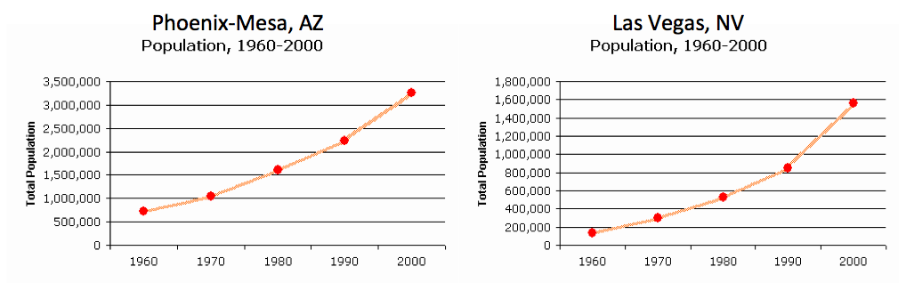

Analysis –
- Are Arizona and Nevada in the Upper or Lower Basin of the Colorado River Pact states?

- How might the change in population affect the amount of water needed by the cities?

- How does this information relate to the information in the Colorado River Pact of 1922?

Part 6- Looking Forward

Congress will be meeting shortly to reevaluate the effectiveness of the Colorado River Pact of 1922. Your group, now well versed in the story of the Colorado River, has been charged with presenting to your local Congress member a case for either accepting the Colorado River Pact as it is, accepting the Colorado River Pact with revisions or rejecting the Colorado River Pact and proposing a new plan to regulate the use of the Colorado River. You will need to provide solid evidence to support your argument,- WHY are you make that suggestion?

Factors to think about may include: population changes, land usage, streamflow changes over time, climate changes, what does it mean to have fair or equitable use, what can be done to help use less water, or use water more efficiently, what are other places in the world doing to help with their water dilemmas? An additional set of graphs of the volumes of Lake Mead and Lake Powell (Graph 3) has been included as an additional resource.
Graph 3- Lake Mead and Lake Powell End of Month Elevations
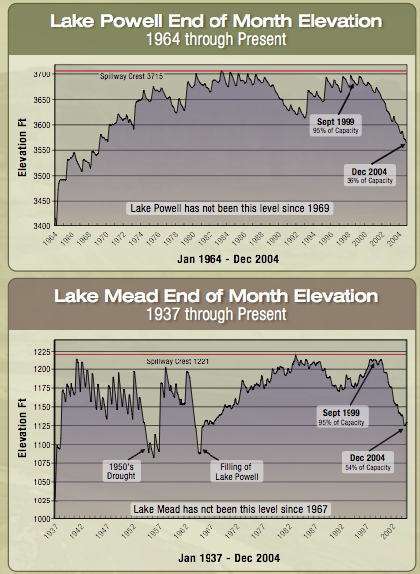
Fulp, Terry. (2005) How low can it go? Southwest Hydrology, p. 16-17, 28.
http://d32ogoqmya1dw8.cloudfront.net/files/eslabs/drought/how_low_can_go.pdf
and linked from “Drying of the American West” http://serc.carleton.edu/eslabs/drought/6a.html

