The Contamination of Surface and Groundwater in Springfield, USA
(Modified from “Who Polluted Surface and Groundwater in This Place?” from http://serc.carleton.edu/NAGTWorkshops/intro/activities/25300.html by Stephen Reynolds, ASU)

Learning Objectives: Students will be able to:
- Determine the direction water is flowing underground based on topography
- Identify sources of pollution in ground/surface water
- Select new sites for wells based on geological evidence

Standard Assessed:
- PA Science Standards:
  - 3.3.7.A4- Differentiate among Earth’s water systems.
  - 3.3.7.A6. MODELS/SCALES- Locate significant geological structures using various mapping representations.
  - 3.3.8.A6 MODELS – Explain how satellite images, models, and maps are used to identify Earth’s resources
  - 3.3.12A CONSTANCY/CHANGE – Infer how human activities may impact the natural course of Earth’s cycles
  - 4.2.8.A – Describe factors that affect the quality of ground and surface waters
  - 4.2.10.A – Examine the interactions between abiotic and biotic factors within a watershed
    - Describe how topography influences the flow of water in a watershed
    - Investigate and analyze the effects of land use on the quality of water in a watershed
- NGSS Performance Expectations:
  - MS-ESS3-3 – Apply scientific principles to design a method for monitoring and minimizing human impact on the environment
  - HS-ESS3-4 - Evaluate or refine a technological solution that reduces impacts of human activities on natural systems

Grade Level: Designed for 7-9th grade students, but with modification can be made more challenging for high school students.

Prep Time: Teachers should always try activities before administering to students

Time to Complete: 1-2 (45 minute) class periods, depending on background knowledge needed by students before starting the activity.

Materials:
- Copies of worksheets for students
- Copies of tables for students or groups
- Markers (red, black and blue), and pencils

Prior Knowledge Needed: Students should have a working knowledge of rock types, permeability and the skill of contouring. Contouring can be taught as a mini lesson prior to the activity.

The Contamination of the Water in Springfield, USA
(Modified from “Who Polluted Surface and Groundwater in This Place?” from http://serc.carleton.edu/NAGTWorkshops/intro/activities/25300.html by Stephen Reynolds, ASU)
You and your colleagues have been called in to examine part of a watershed of Springfield, USA. Contamination has recently been discovered in their water system. The local scientists have measured levels of contamination at various well and stream sites, in addition to gathering the existing information on the geology of the area. You will have access to 2D and 3D maps of the area and the stratigraphic column of the region. The city has requested your help in using the scientists’ data to determine the source of the pollution is in Springfield’s water.
During the activity you will label the water table level at sampling sites in the area and use that information to create contour maps. This will allow you to better see the topography of the sampling site. Then, you will label the contamination sites on a map of Springfield and use the information to determine where the contamination originated. Finally, using your knowledge of the area, you will determine what is the best place for Springfield to drill new wells to avoid contamination problems in the future.
Mapping Tasks:
Figure 1 shows the locations of:
- wells (lettered A to P)
- samples from springs (S1 to S4)
- sample of river water (R1 to R8)
- human made features (farms, factories, mines, etc. named)
- roads (gray lines)
Using the map, complete the following tasks:
- Label the water table elevation at each well
- Draw contour lines in increments of 10 based on the subsurface water table elevation
- Use the contour lines draw arrows indicating which way the water flows.
- Using the data in Table 1 to circle contamination sites in red. Label the contamination level next to your circle.
Notes
- A recent geologic study has shown Slidetown and Springtown industrial sites are NOT sources of contamination.
- Contamination can follow permeable units through the subsurface, but is less likely to travel down through less permeable units even though the water table is shown as cutting across the units (which it does).

Extension Activity: What other measures can Springfield, USA collect to inform the prevention of contamination of the watershed in their region? You may want to do additional research on this information.
Possible resources: NOAA:http://www.education.noaa.gov/Freshwater/Watersheds_Flooding_and_Pollution.html
Environmental Protection Agency (EPA): http://water.epa.gov/polwaste/
Riverkeeper:http://www.riverkeeper.org/get-involved/minimize-your-impact/watershed-pollutants/
National Resource Defense Council (NRDC): http://www.nrdc.org/water/pollution/gsteps.asp
You have been asked to decide where the best place to drill a new, uncontaminated well in Springfield. The city planners would like the well to be in a place where this contamination is unlikely to happen again. Where would you drill the well (draw a blue W on the map at these locations) and why?
With your group, carefully examine the map.
1. Shade in with pencil the areas that are contaminated.
2. Where do you claim the contamination came from? What evidence supports your claim? What reasons can you give for those places to be sources of contamination?

Figure 1. Map of Springfield, USA

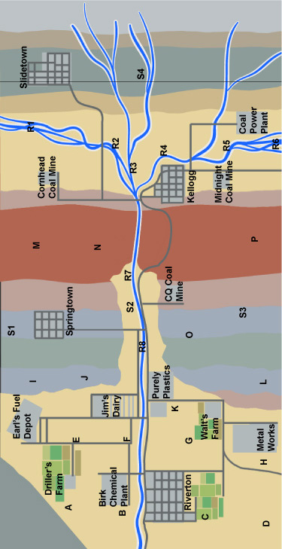
lower sandstone
lower shale
granite
upper shale
middle shale
Sinkerton limestone
Sinkerton limestone
gravel
upper shale
upper sandstone
Sinkerton limestone
middle shale
upper shale

Figure 2. Springfield, USA Stratigraphy
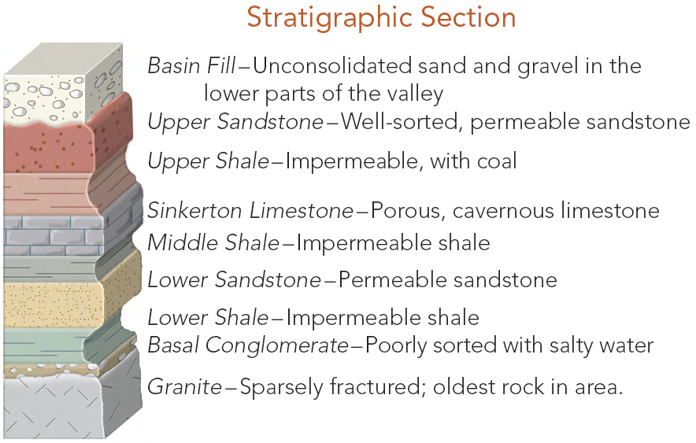
A Stratigraphic Column shows the layers of rock, in order, found in an area. Scientists have taken samples to determine what a layer is made up of and how thick it is. This diagram is a stratigraphy column for the rock layers under Springfield, USA and describes how permeable they are. The more permeable a rock is, the more likely liquids and gasses, like water, can pass through it.

Table 1. Elevations of the Water Table and Concentrations of Contamination
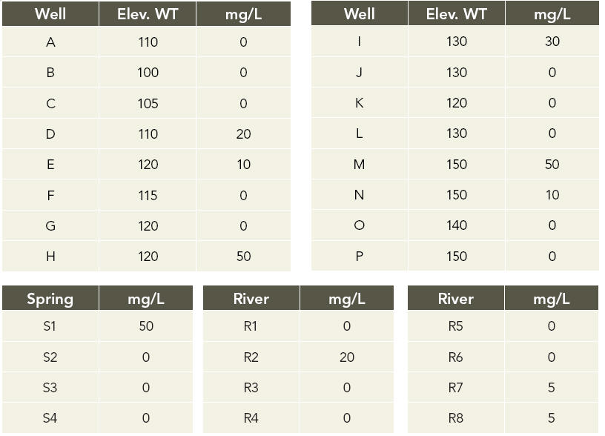

This table shows water-table elevations in meters and concentrations of contamination in milligrams per liter (mg/L) for each of the lettered wells, and the concentration of contamination in samples from four springs and eight river segments. The location of each sample site is marked in the Figure 1- Map of Springfield, USA

