Mountain Building: Exploring topography along plate boundaries with GeoMapApp

Information available electronically in the PAESTA Classroom: http://www.paesta.psu.edu/classroom/mountain-building-exploring-topography-along-plate-boundaries-geomapapp

Mountains are perhaps the most spectacular consequences of plate tectonics and a prime example of earth systems. The growth of topography along active plate margins influences weather and climate, while the erosion of mountain ranges drives large-scale cycling of material on the earth’s surface. For example, the Himalaya and Tibet have formed over the past 40-50 million years, when the subcontinent of India collided with Asia, and during this time the rising mountains deflected the jet stream northward. This deflection is largely responsible for the “loops” in the position of the jet stream that we see in weather forecasts and that carry weather fronts across the United States. It is truly a “teleconnected” world!

At the same time, processes operating in the deep crust during mountain building transform sedimentary rocks into the metamorphic and igneous rocks that we commonly associate with the nuclei of continents. The erosion of these rocks in high mountain ranges provides sediment to basins and thus completes the “rock cycle.” During this exercise we will build on the Discovering Plate Boundaries (DPB) introduction to explore associations between plate tectonics and mountain building.

Introduction: Using GeoMapApp to visualize and measure topography

The topographic maps included in the DPB exercise are wonderful, colorful representations of global topography (and bathymetry), but they are largely qualitative. The goal of this exercise is to use free, publicly-available tools and data that have been developed to make basic measurements of topography along various plate boundaries. GeoMapApp is a free, map-based data exploration and visualization tool developed by the IEDA database group at Columbia University's Lamont-Doherty Earth Observatory (see http://www.geomapapp.org). Using this tool, we will explore how comparison of topography along different boundaries, both ancient and active, can provide a means for students to grasp the immense spatial scales involved in earth processes.

Part 1: Working with GeoMapApp –
By default, GeoMapApp loads with a basemap of topographic (and bathymetric) data generated from a variety of sources. This should be sufficient for most activities, but as you develop sophistication, you may try exploiting different data sources. There is a fairly sophisticated help page available at: http://new.geomapapp.org/gma_help/GMA_userguide.htm.

Part 2: Creating a path and extract an elevation profile –
For this operation, there is a specific tool, aptly named the Profile/Distance tool. It has an icon that looks like this . Specific instructions on its use can be found in section 6.5 of the user guide, but I have tried to simplify them below
- Open GeoMapApp, and zoom to the region of interest.
- Click on the Profile/Distance tool. This will automatically enable a cursor that looks like a crosshairs. With this, click on one end of a path. Hold the mouse, and drag to the other end of your desired path.
- When you release the button, a graph will appear inside a new dialogue box. This is the elevation along the path, plotted against distance. NOTE: the resolution of the data depends on the scale of your map. If you want finer detail, you need to zoom in before you draw the path.
- The dialogue box allows you to choose a number of parameters. Perhaps most important of these is the vertical exaggeration. This is the difference between the vertical and horizontal scales. Play around and change this a bit to develop a feel for what “true” scale shows (zero exaggeration).
- Save the plot. Using the menu at top left, choose what format you prefer. There are two image formats (JPEG and PNG), as well as a data table (ASCII), which may be useful if you want students to plot some of the data by hand.

Part 3: Comparison of active mountain belts –
In this exercise, we will examine topography in active collisional mountain belts. You are free to decide how many, and which, mountain ranges you will examine. For simplicity, I have here chosen two – the European Alps and the Himalaya/Tibetan Plateau. First, compile materials.
- Extract elevation profiles across the Alps and the Himalaya/Tibetan Plateau.
- Print image of both profiles for analysis (NOTE: be sure to maintain the same vertical exaggeration in each).

Questions to consider:
- Look at each topographic profile. What are the characteristics of each? How high are the peaks? How deep are the valleys? The difference between these is the relief in the landscape. What is the maximum relief in your profile?
- How does relief compare between the Alps and the top of the Tibetan Plateau?
- Using a ruler, measure the area of the topography above sea level in each cross section (example below). How does the size of the Alps compare to Tibet?

Examples of calculations (Please note, these images are from Google Earth. The principle is the same):

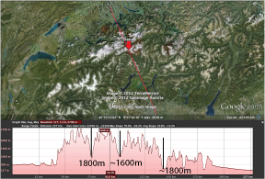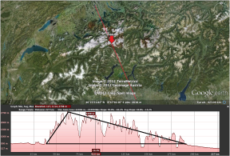
Relief in the Alps Area of cross-section of the Alps

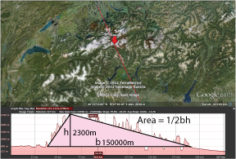 Answer (A=172500000 m² or 172.5 km²)

Note also that your calculations will be somewhat different, depending on the endpoints you choose for the cross-section. If you want to maintain the exact same profile, you can enter the coordinates (latitude, longitude) in the dialogue box.

Part 4: Ancient mountain chains –
Using similar methods, extract profiles across the Appalachians and the Urals.

Questions to consider:
- How does the topography (relief, cross-sectional area) of these ranges compare to active mountain ranges?
- What does their position tell us about ancient boundaries?
- What claims can one make related to continental collisions that have occurred in the past? What additional information would you like to have as evidence in support of your claim?

