Rain and Rivers -- An introduction
Prepared by Laura Guertin (Penn State Brandywine) and Tanya Furman (Penn State University Park)

Let's look at some data collected in Pennsylvania rivers. Examine the two streamflow discharge graphs presented on the next page (page 2). Streamflow is measured in units of cubic feet per second - in other words, how many cubic feet of water pass through a stationary measuring point each second.
Across the very top of each graph are the letters USGS (United States Geological Survey, the federal organization that oversees water monitoring and investigations in the United States), a USGS identifier number, and the name of the river with the city and state where the data were collected. The upper graph is for a stream located just to the west of Philadelphia in the city of Media, while the Susquehanna River measurement was taken where the stream flows through Harrisburg. On the X-axis, you can see the date. Measurements were collected during a one-week period in the summer of 2005. On the Y-axis, you see the streamflow dischrage represented.
What do you notice about these graphs first? Well, you can't help but notice the blue line going across. This blue line represents realtime water data, collected at 15-60 minute intervals. Notice that the Ridley Creek graph shows a significant peak on July 8, while the Susquehanna River graph shows a small increase. What might have caused the increase in streamflow to be so different between these two locations?
Well, if you remember back to summer 2005, it was quite a crazy year for hurricanes. On July 8, the remnants of Hurricane Cindy passed through the Philadelphia region, pouring down a large volume of rain. Where does all of that rain go? Much of it gets absorbed into the ground and enters soil layers and the groundwater systems, but some of it will "run off" into local streams, such as Ridley Creek. Those rainfalls didn't reach Harrisburg, so the streamflow record there was not impacted as significantly - or was it? Notice that the scale on the Y-axes of the two graphs below are different! Overall, the streamflow in Ridley Creek is much less than the streamflow in the Susquehanna River, so be sure to pay careful attention to the scale of the axes when you make interpretations.
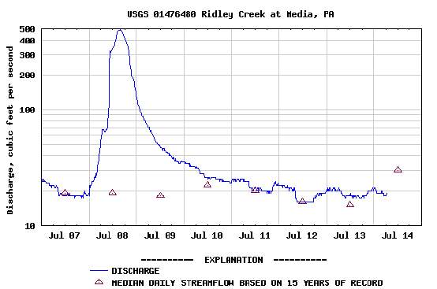
Ridley Creek hydrograph for 2005. Source: U.S. Geological Survey.
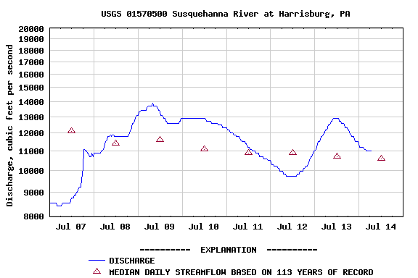
Susquehanna River hydrograph for 2005. Source: U.S. Geological Survey.
But what else do you see on these graphs? Yes, there are red triangles. Those triangles represent the median streamflow discharge for that date. As you can see, the Ridley Creek station has been collecting data for the past 15 years, while the Susquehanna River station has been in place for 113 years. How do these data compare with the 2005 record?
The graph below shows a much longer record for Ridley Creek, with the blue line representing the daily mean streamflow discharge from July 2005 to January 2006. Instead of red triangles, we have a red/brown line showing the median daily streamflow for the past 15 years. Can you think of reasons why there are more significant variations in the 2005-2006 record than in the record from the past 15 years? What causes the variations, or "wiggles," in the first place? You have the example of Hurricane Cindy, but that doesn't explain what may impact streamflow in the winter months. How do you think the 2005-2006 streamflow record will affect the median streamflow record?
