EarthKAM Step II Instructions

The EarthKAM Final Project will require that you annotate (label) about a dozen features in your photo image. It might look something like this when you are finished:

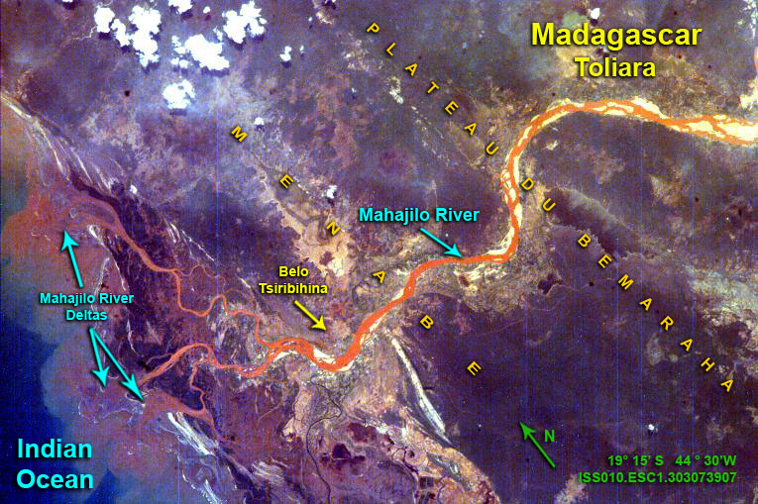

Your picture from space has absolutely NOTHING labeled in it, so you will need to find out what and where it is located. The only way to easily do this will be to use Google Earth, the standalone program available for free online.

Instructions:

- Navigate to: http://www.google.com/earth/explore/products/desktop.html
Note: It is possible to do this on a tablet, but it is much more difficult. I recommend using a mac or windows desktop or laptop. Maybe Chromebooks too?

The Pro version of Google Earth is now free, but I do not have experience with it and so my advice is that you download the non-pro version.

- Type your full latitude and longitude into the search bar in the upper left:
you can copy and paste it from the EarthKAM image page
example: 21.59° N, 81.86° W Don’t forget the comma!
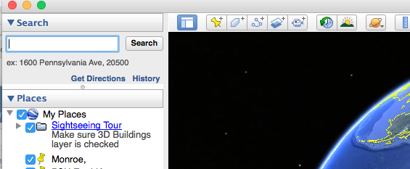
- Google Earth will zoom WAY in to a very close version of your particular place on Earth. Do not be concerned if it looks nothing like your picture from the ISS.

- Uncheck all the blue checkboxes in the lower left area called “Layers” See below:
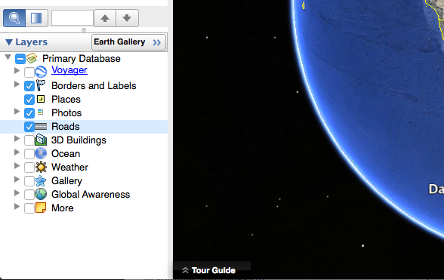

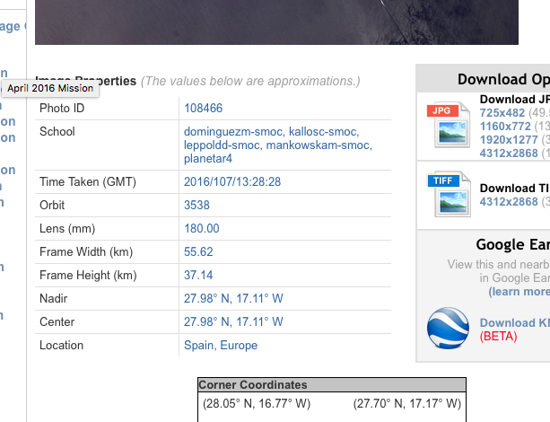

- Determine from the
EarthKAM image page
if the lens for your image is
50.00mm or 180.00mm.
This is how zoomed in your
image is and is critical.

- Zoom out (up) from your image using the scroll wheel, the trackpad, or by clicking the “-“ button in the upper right:
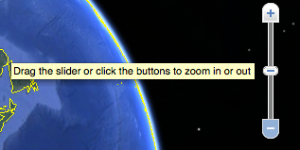
- If you had the 50mm lens, zoom out to an “eye altitude” (lower right hand of screen) of about 100 miles:
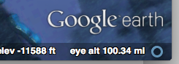
If you had the 180mm lens, only zoom out to about 27 miles:
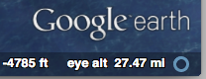

- Click and drag to rotate the “N” (North) on the compass until it looks about like this:
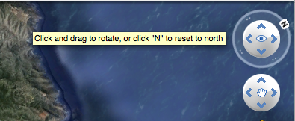

- Center and adjust the zoom for the image in google Earth so that the image looks very much like your EarthKAM image. It helps to have them side by side on your computer screen:
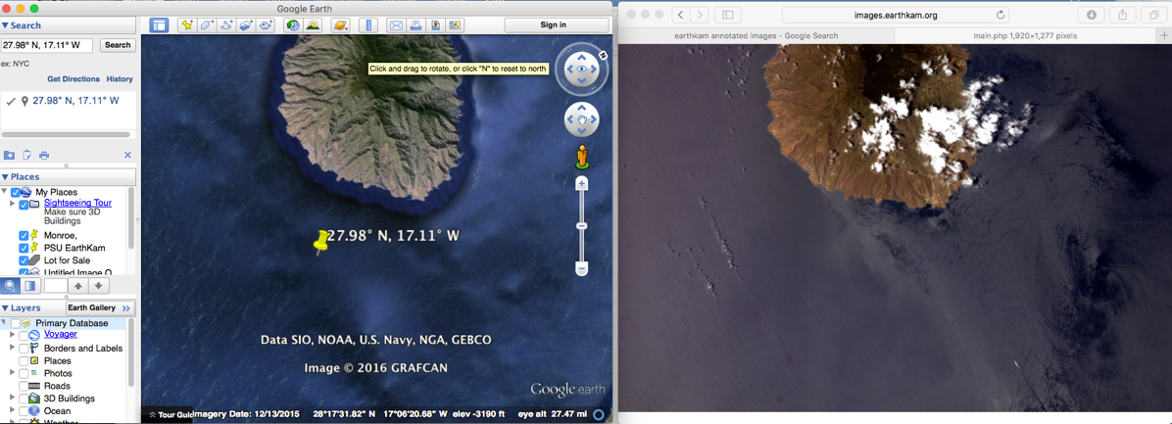

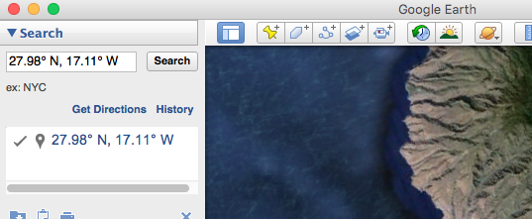
- Finally, click the “Push Pin” button to save your location on the computer that you are using. Change the name from “Untitled Placemark” to your name and the image number. Example: “JohnSmith-Image_98554”

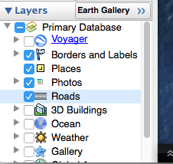
- Re-check these four blue “Layers” buttons:
Doing this will allow you to see
what named areas you
have in your image

- Finally, save that Push Pin location from Google Earth to your CRSD google drive. Click to highlight your pushpin that you just saved, then under the “File” menu, choose “save place as” and save it to your computer and then drag it to your google drive while you are still logged in to google classroom. You can also right-click it and select “Save Place As…”

The file you save should have a “.kmz” file extension as the last three digits in its name:
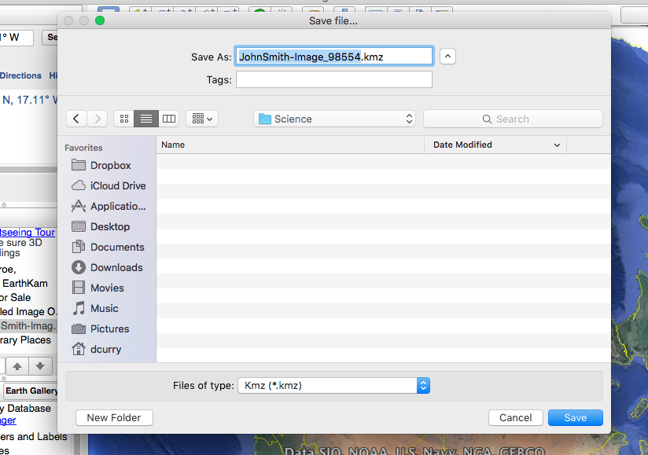

- You are now ready for EarthKAM Step III!

