The Physical and Biological Characteristics
of the
World’s Seven Biomes

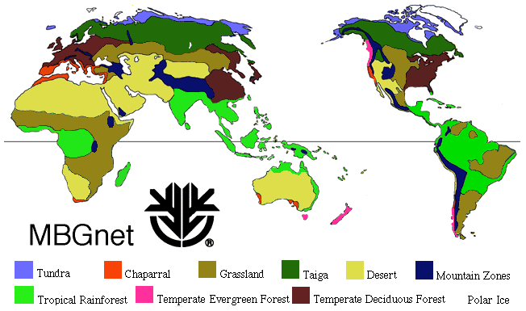

Name: __________________________________

Date: __________ Section: ___________

