Stories from the Earth:
Reading the rock record of ancient environments

This activity is modified from one originally developed by Tanya Furman at Penn State University. Versions of this exercise have used in classes with students ranging in age from middle school through college. It can be adapted for various levels quite easily, either through the specific questions asked or the degree of independent research required. As always, please encourage students to read the materials completely and carefully before they begin writing. The activity as written is streamlined to fit within a 1-2 hour time period. It has two connected parts; the second can be used for differentiated instruction or omitted if time is limited.

Project Goals:
1. Map skills
2. Measurement skills
3. Analysis of natural data
4. Making graphs by hand
5. Interpreting geological information in plate tectonic context
6. Claims / Evidence / Reasoning

Background
Sedimentary rocks provide insight into the changing environments of the past. You already know how to identify several key sedimentary rock types, and have an understanding of the conditions under which they formed. In this exercise you will look at sedimentary sequences that record the history of the western United States from the PreCambrian through the age of the dinosaurs. You will evaluate data on two different spatial scales: (a) variations within Grand Canyon, and (b) differences between rocks at the western and eastern ends of Grand Canyon. The stratigraphic columns used in this exercise were developed by Dr. Ronald Blakey at Northern Arizona University and obtained through the Digital Library of Earth Science Education. All of the geological information that you need is provided here, but you will need to consult a good regional map (search online for maps of the Grand Canyon region).

The goal of this exercise is for you to apply understanding of sedimentary rocks to paleo-environmental reconstruction, in which ancient sedimentary and tectonic environments can be determined over thousands of kilometers and hundreds of millions of years. You will see the tremendous power of sedimentary rock identification! You will also start to recognize the spatial and temporal scales over which geological processes operate, and that knowledge is essential for deep understanding of plate tectonics and geology. In addition you will gain valuable experience using algebraic manipulations and applying quantitative reasoning to natural data, forming an easy bridge to mathematics.

Assignment:

Part 1: Changing environments through time

Examine the map of the Grand Canyon and note the location of the five marked stations. There are five associated stratigraphic sections, and each group is given one of these. Please note that the scales are not the same on each stratigraphic column, so you will need to make any measurements individually. Initially, we want to focus on a single time period, the Cambrian. Rocks deposited during this time comprise the “Tonto Group” and are subdivided into three primary rock formations. As you answer the following questions, refer to the “Explanation for Stratigraphic Columns” as a guide to the symbols used to represent various rock types.

- In your section, what rocks underlie the Tonto Group? Describe the nature of the boundary between these different rock packages. What is the significance of this boundary?

- Measure the thicknesses of each of the three rock formations in the Tonto Group. Note these on your section.

- What are the primary rock types of each formation? What paleo-environments do each of these rock types represent?

- Discuss briefly the significance of how paleo-environments changed through time at your locality. What can you say, if anything, about relative water depth?

Now we want to shift focus to a second time period, during the Pennsylvanian and Permian Periods. Rocks deposited during this time comprise the “Supai Group” and are subdivided into a series of rock formations. As above, measure the thicknesses of each of these formations, note the rock types, and interpret the paleoenvironments.

- Measure the thicknesses of each of the rock formations in the Supai Group. Note these on your section.

- What are the primary rock types of each formation? What paleo-environments do each of these rock types represent?

- Discuss briefly the significance of how paleo-environments changed through time at your locality. What can you say, if anything, about relative water depth?

Part 2: Changing environments across space

The second part of this activity is designed to compare differences between each section. You will work as an entire class to interpret how the rock types and paleo-environments represented in your section are related to others.

On the chalkboard (or overhead), we have created a graph that shows distance from west to east on the horizontal axis and height above an arbitrary datum on the vertical axis. In our case, the datum we will use is the Great Unconformity at the base of the Tonto Group. Each group should plot the height of the top boundary of each rock unit at the appropriate position of their section. Note: the height should be the cumulative thickness from your measurements in Part 1.

In your group, answer the following questions:

- During Cambrian time, how do the thicknesses of rock units change from west to east?

- Based on these variations, can you infer which the ancient shoreline would have been?

Now, go back to the board and plot the data from the Supai Group on the second graph (provided). Note here that the datum we are plotting above is also a regionally-extensive unconformity.

- During Pennsylvanian and Permian time, how do the thicknesses and rock type of formations within the Supai Group change from west to east?

- As above, where might the ancient shoreline have been?

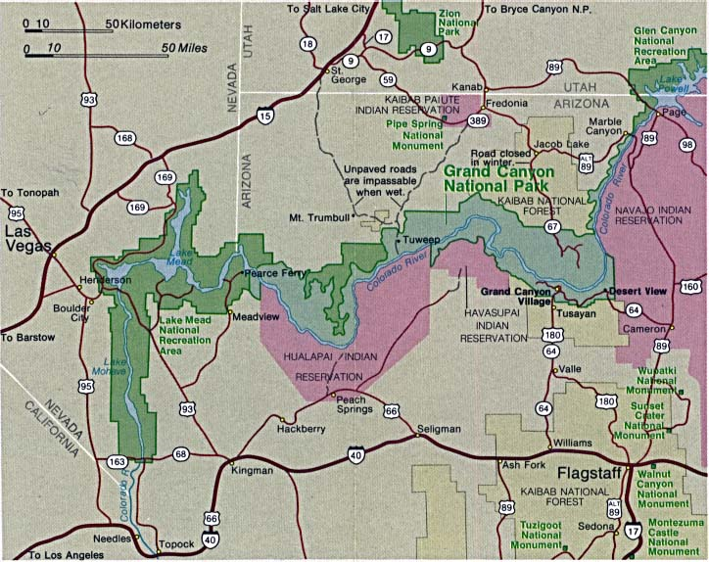
Nankoweap Canyon
Kanab Canyon
Diamond Creek
S. Kaibab Trail
Grand Wash Cliffs

Getting additional information:
There are several web sites that purport to describe the geological history of the Grand Canyon region. Many of these sites are not written by geologists (in fact, many of them are written by creationists) and you may end up confusing yourself if you spend time with them. If you want more reliable information, I recommend this site, which has detailed descriptions of the rock units that provide important environmental insights:
http://www.und.nodak.edu/instruct/mineral/101intro/grandcanyon/grandcan.htm
Bear in mind that the document you hand in must reflect the materials provided in this exercise. For that reason, it is a very bad idea to simply copy anything from the web sites without verifying that it matches your specific sections.

Below is the legend that applies to each of the stratigraphic columns.



