Mountain Building: Appalachians v. Urals

Below are two transects across ancient mountain ranges in the Appalachians and the Urals.

Location Maps:

APPALACHIANS: (profile extends from -80.5°E, 40.5°N to -76°E, 38.5°N)

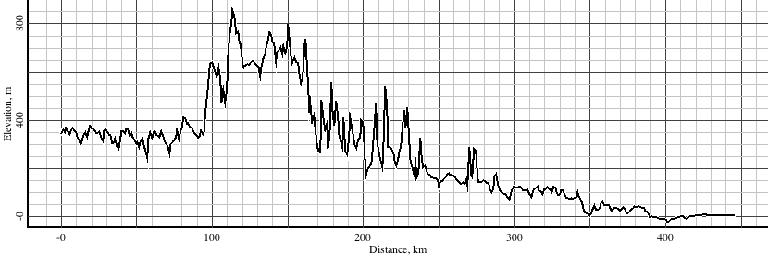

URALS: (profile extends from 54.5°E, 60.5°N to 63.5°E, 60.5°N)

