Coal and Plate Motion Activity and Discussion
(to follow coal resources activity after map with U.S. coal resources is shown)
Developed by 2008-2009 TESSE Graduate Fellows from Penn State University (www.tinyurl.com/tessedissemination)

Objectives:

Students will:
- Review the prime environmental conditions for the formation of coal.
- Use paleomaps to examine plate motions from the Silurian to the Late Cretaceous and identify the main coal-forming period in Pennsylvania. (located in separate document)
- Use paleomaps to explain the distribution of coal in other regions of the United States.

Materials:
- U.S. Coal reserves map (two examples provided)
- Color copies of 5 Scotese paleomaps (Silurian, Devonian, Early Carboniferous, Late Carboniferous, and Late Cretaceous)
- Western Interior Seaway map
- Late Cretaceous Climate map
- Photos of U.S. swamps and illustrations of PA swamps 300 Ma
- World coal map for assessment exercise

Assessment:

- Using the paleomaps and/or Western Interior Seaway map, identify a region outside the United States where you would expect to find coal resources. Write a paragraph explaining the reasoning behind your hypothesis. At the start of the next day, pass out copies of the World Coal Reserves map. Ask the students add on to the paragraph they wrote the day before by writing a couple sentences telling whether their hypothesis was correct or not. If their hypothesis was incorrect, they should speculate on why coal reserves were not found in that location. Make sure that the students keep their original hypothesis from the previous day. What is important is that the reasoning behind the hypothesis is logical and agrees with what is shown on the paleomaps. Scientists do not always find what they expect to see in their experiments and studies. They form new hypotheses as they disprove old ones.

*Maps for this activity are found at the end of this lesson plan & online at the TESSE site*

Each student should have a copy of the U.S. Coal resources map and the 5 Scotese paleomaps. The teacher can also show the images on an overhead or power point presentation.

Discussion Questions:

- What environmental conditions would have been present in the states containing coal reserves during the time of coal formation?
- A substantial amount of plant material is needed, as is a way to protect the dead plant material from decay. Tropical, swampy environments contain abundant vegetation. Fallen leaves, twigs, branches, and trunks accumulated at the bottom of the swamp, and the stagnant swamp water allowed the dead material to be better preserved. Rivers overflowed into the swamps, depositing layers of sand and mud above the organic material, burying and compressing it. Seas also transgressed onto the land covering the swamps and depositing marine mud.

- Are such conditions present today in Pennsylvania?
- Pennsylvania does not have a tropical climate. Swamps aren’t present in areas of PA where coal is found today.

- What made it possible for these conditions to exist in the past?
- Encourage the students to identify which parts of the globe currently experience tropical and swampy conditions. They should reach the conclusion that countries along the equator are in the tropical zone. In order for coal to form in PA, tropical conditions must have existed at one time in our state. At this point, the teacher may want to show the students pictures of current swamps in Florida and the Mississippi River Delta as well as illustrations of what Pennsylvania would have looked like ~ 300 Ma.

Break the students into small groups to examine the paleomaps. You should first look at one of the maps together and discuss what the various outlines and symbols mean on the maps. It is especially important for them to be aware of the fact that large portions of land were underwater during these periods as sea level fluctuated.

- Look at the paleomaps for the following periods:

- Silurian (425 Ma)
- Devonian (400 Ma)
- Early Carboniferous (350 Ma)
- Late Carboniferous (300 Ma)
- Late Cretaceous (100 Ma)

Mark the approximate location of PA on each map. During which period is it most likely that coal formed in Pennsylvania and why?

- The Late Carboniferous was the great period of coal formation in the United States. Pennsylvania was closest to the Equator during this period. As the North American plate moved across the equator, Pennsylvania became a tropical rainforest. If the North American plate had never moved across the equator, PA would not contain the vast coal resources it does today.

Tell the students to look again at the 5 paleomaps.

- Do the paleomaps give you any indication as to when the coal reserves to the west (near the Rocky Mountains) formed?
- The students should see a similarity in the shape of the sea cutting through North America in the Late Cretaceous map and the distribution of coal in the US coal resources map.
- During the Cretaceous a huge inland sea called the Western Interior Seaway cut through North America. As the Pacific and North American plates collided, the Rocky Mountains formed in the western U.S. High sea levels during this time led to flooding of the lowlands to the east of the Rocky Mountains. Waters from the Arctic Ocean to the north and the Gulf of Mexico to the south met to form the seaway that grew and receded during this period.
- Swamps and lagoons existed along the coast of the seaway. Swampy conditions were also present within the seaway as the water moved in and were left behind as it receded. Marine mud and silt were deposited on top of the dead swampy matter when the seaway became deeper and calmer as the sea moved inland. This mud and silt buried and compressed the layers of organic matter below, starting the process of coalification.

Pass out the Western Interior Seaway map or show it in the powerpoint. This map will clarify the geographic extent of the seaway. Have the students draw the outline of the seaway on their US Coal Resources map. One student could also draw the outline on an overhead sheet if available. This should confirm the correlation between the seaway and the coal deposits. Point out the relationship between the seaway and coal deposits along the Gulf Coast as well.

Students may notice that the regions of the Western Interior Seaway in which coal formed were not close to the equator at that time. This will seem contradictory from what they learned about the formation of coal in PA. Show the Late Cretaceous Climate map. Explain that during the Late Cretaceous, the global mean surface temperature was about 5°C warmer than it is today and no ice existed at the poles. The U.S. was located in a warm temperate zone where the conditions were still suitable for coal formation.

Maps for Day 3

Coal Reserves in USA
American coal Foundation (2010) - http://www.teachcoal.org

Coal Reserves in USA (poster)
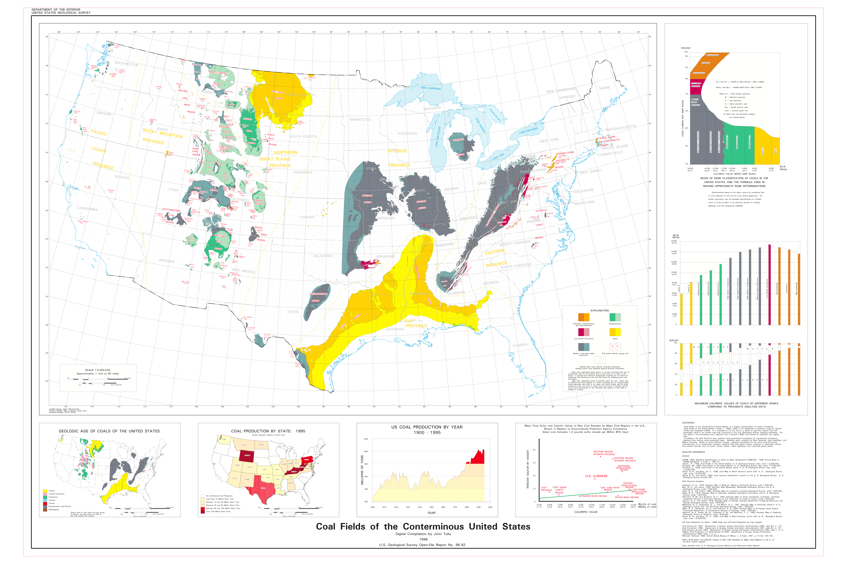
from USGS (1996)

Western Interior Seaway Map
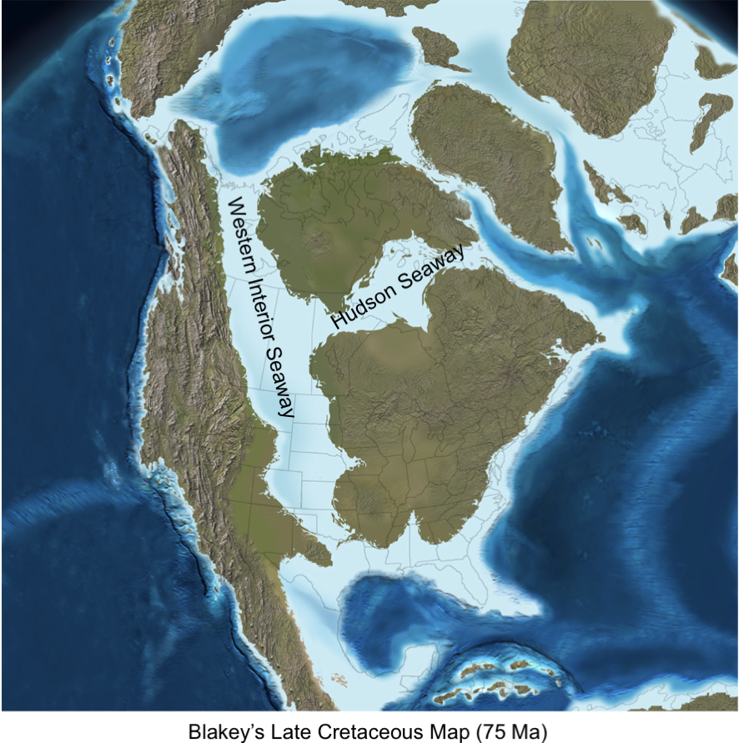

World coal Deposits
Maps of the World (2006)

Late Cretaceous Climate Map
http://www.scotese.com/lcretcli.htm

